1DV503/1DT903 Database Technology and Modeling

Jesper Wingren

School of Computer Science, Physics

and Mathematics, Linnaeus University, Sweden

[jw223rn@student.lnu.se](mailto:jw223rn@student.lnu.se)

***Assignment 2***

**Task 1:**

**A.**

{Manufacturer,serial number} -> Model, Batch, Capacity, Retailer  
**B.**  
Model number -> manufacturer  
**C.**  
Batch -> Model

**Task 2:**

The relation is in 1NF because it has a primary key that uniquely identifies each  
record and it doesn’t contain any multivalued or nested relations. But the relation is not in 2NF or 3NF because it contains an attribute that is not dependent on the whole primary key, for example the commission is only dependent on the salesperson. And for the relation to be 3NF it must first be in 2NF and it is not allowed to have a nonkey attribute dependent on another nonkey attribute, but the discount is dependent on the date_sold attribute which leads to it not being 3NF.   
  
To normalize it completely you first need to make it 2NF by splitting it into two different relations, CAR_SALE_1(Car,Date_sold,Discount) and CAR_SALE_2(Car,Salesperson, Commission).  
To normalize it into 3NF we split the CAR_SALE_2 into two new relations, CAR_SALE_3(Car,Salesperson) and COMMISSION(Salesperson, commission).  
With these relations all attributes are fully dependent on the primary key of each relation and no transitive dependencies exist. Thus, the relation is 3NF.

**Task 3:**

**A.**

Query:

SELECT fname,lname

FROM EMPLOYEE AS E

INNER JOIN WORKS _ON AS W ON E.ssn = W.essn

INNER JOIN PROJECT AS P ON W.pno = P.pnumber

WHERE P.pname = ‘computerization’;

Output:

**B.**

Query:

SELECT pnumber,dnumber,lname,address,bdate  
FROM PROJECT AS P  
INNER JOIN DEPARTMENT AS D ON P.dnum = D.dnumber  
INNER JOIN EMPLOYEE AS E ON D.mgrssn = E.ssn  
WHERE plocation='Houston';

Output:

**C.**

Query:

SELECT E.fname,E.lname,S.fname as supervisor_fname,S.lname as supervisor_lname  
FROM EMPLOYEE AS E  
LEFT JOIN EMPLOYEE AS S ON E.superssn = S.ssn;

Output:

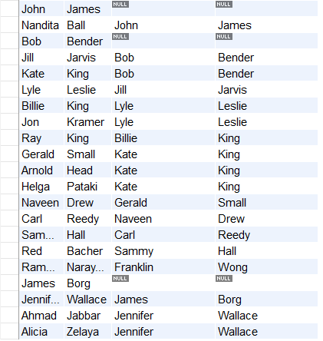

**D.**

Query:

SELECT *  
FROM EMPLOYEE  
WHERE address LIKE '%Atlanta, GA';

Output:

**E.**

Query:

SELECT *  
FROM EMPLOYEE  
WHERE MONTH(bdate)='11'

Output:

**F.**

Query:

SELECT dname, AVG(E.salary) as average_salary  
FROM EMPLOYEE AS E  
INNER JOIN DEPARTMENT AS D ON E.dno = D.dnumber  
GROUP BY D.dname;

Output:

**G.**

Query:

SELECT fname,lname  
FROM EMPLOYEE AS E  
LEFT JOIN WORKS_ON AS W ON E.ssn = W.essn  
WHERE W.essn IS NULL;

Output:

**H.**

Query:

SELECT fname,lname  
FROM EMPLOYEE AS E  
INNER JOIN WORKS_ON AS W ON E.ssn = W.essn  
INNER JOIN PROJECT AS P ON W.pno = P.pnumber  
INNER JOIN DEPARTMENT AS D ON E.dno = D.dnumber  
WHERE D.dnumber = '5' AND E.salary > '30000' AND P.pname = 'ProductZ';

Output:

**I.**

Query:

SELECT fname,lname  
FROM EMPLOYEE AS E  
INNER JOIN DEPARTMENT AS D ON E.dno = D.dnumber  
WHERE E.address LIKE '%Houston, TX%' AND D.mgrssn = '333445555';

Output:

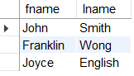

**J.**

Query:

SELECT fname,lname  
FROM EMPLOYEE AS E  
INNER JOIN DEPARTMENT AS D ON E.dno=D.dnumber  
WHERE D.dnumber = (  
SELECT dno  
    FROM EMPLOYEE  
    GROUP BY dno  
    ORDER BY MAX(salary) DESC  
    LIMIT 1  
);

Output:

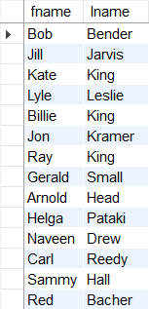

**K.**

Query:

SELECT dnumber,dname,COUNT(ssn)  as num_employees  
FROM EMPLOYEE AS E  
INNER JOIN DEPARTMENT AS D ON E.dno = D.dnumber  
GROUP BY D.dnumber,D.dname  
HAVING AVG(E.salary) > '30000';

Output:

**L.**

Query:

SELECT dependent_name,relationship  
FROM DEPENDENT AS DE  
INNER JOIN EMPLOYEE AS E ON DE.essn = E.ssn  
WHERE E.superssn = '333445555'  
ORDER BY DE.dependent_name ASC;

Output:

